Changes for website
- On podcasts page, can you please change time for how long episodes are under ‘how long are episodes’ from 30-45 minutes to 20-30 minutes
- On the same page, under When will episodes start?, can you change “We're targeting Q1 2026 for our first episodes. Subscribe to get notified” to “We’re recording, and it won’t be long before our first episodes! Subscribe to our newsletter to be the first to hear.”
- On events page, for the webinar, please remove the date and ‘234 going’

- 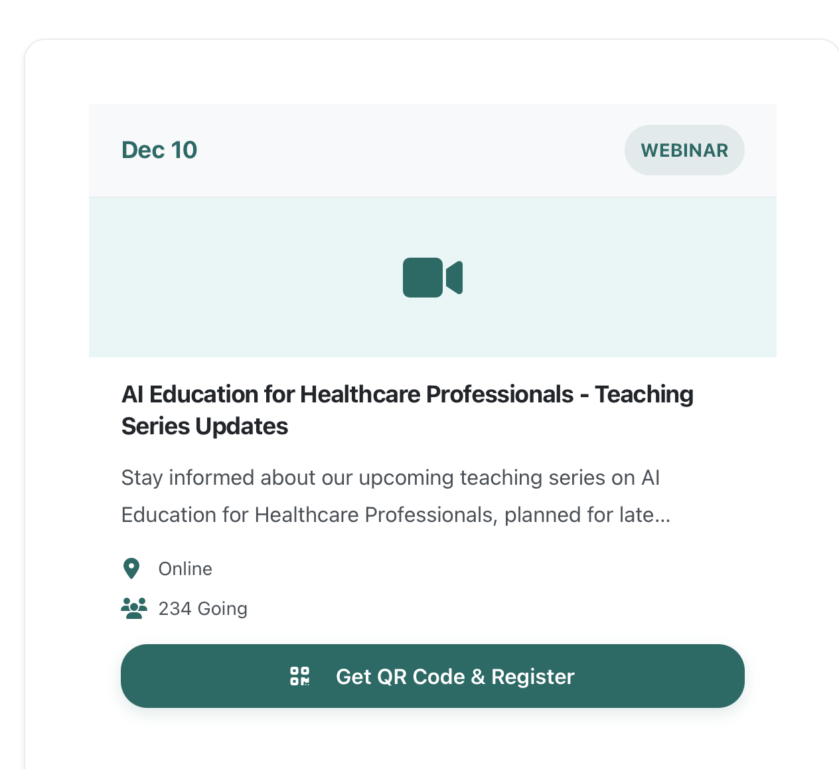
- Under ‘featured events this month’ on the events page:
  - Firstly, change the title from ‘featured events this month’ to ‘featured events’
  - Change “Join our weekly webinars covering the latest AI trends and practical applications” to “Join our newsletter to hear about the upcoming webinars”
  - Change the middle box (featured events) where is says monthly. Change ‘monthly’ to “Coming soon”
- On the courses page, under ‘courses in development’:
  - Keep the first course “AI Fundamentals for Healthcare”
  - Change second course name from “ChatGPT & LLMs for Medical Professionals” to “How to leverage ChatGPT and LLMs as a busy working professional”
  - Change “AI Ethics & Responsible Implementation” to “AI automation”
  - Leave final course as it is: “Building AI-Powered Clinical Tools”
- On the courses page, under FAQ,
  - Change the answer for ‘How long are the courses?’ – make the answer to “Courses are 2-12 weeks long depending on complexity and depth.”
- Finally, on the newsletter page, change “Join thousands of professionals staying ahead with AI” to “Join the newsletter to work smarter, not harder, with AI.”

  - 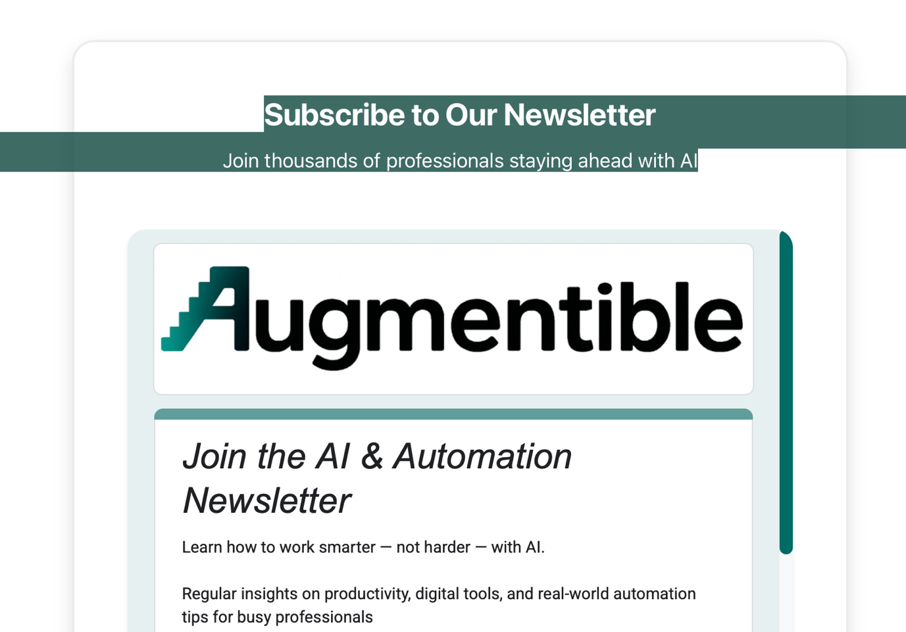
- Finally, in the pink box I’ve drawn, can you create a new column
  - Heading should be: Augmentible Ltd. ©
  - Underneath it should say “Company number 16807620”
